**MiSight® Social Media and Community Management Toolkit**

**ECP Social Media Content – Post Copy**

**Instructions:** Copy/paste post copy into Facebook or Instagram (please include the footnotes). The high-resolution graphic images and videos can be downloaded [here](https://dixonschwabl.sharefile.com/share/view/sda4a608c88354cb59eb3481a6e1b1d21).

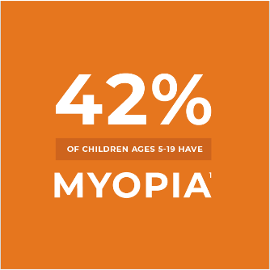**Post #1: (2-image swipe)**

Myopia is on the rise. For age-appropriate* children, MiSight® 1 day can help. It’s the first and only‡ FDA-approved* soft contact lens to slow myopia progression in children aged 8-12 at the initiation of treatment.2§

Learn more about [#myopiacontrol](https://www.facebook.com/hashtag/myopiacontrol?__eep__=6&__cft__%5b0%5d=AZW0tNJF3TRGw2OEU_1wosO3AqIFj5P3TAGqHkCmjPRm3euvk2l9zHOE58pRNIEb1Xe6FFb0Tp01iKROcRrD6FbO6Ya8QNyOtig-ThCLHoH9xdcDaWhJFlh0GWit61d-QWqe1lJ33d7lznssVzpHIYmX91w6Ih0s6zPTC1KgQpQgsRZ9i6P-3ozVK95YLLHN34Y&__tn__=*NK-R) and find an eye care professional near you: [bit.ly/3mhWQf7](https://l.facebook.com/l.php?u=https%3A%2F%2Fbit.ly%2F3mhWQf7%3Ffbclid%3DIwAR1QfZtFtShYbGiYejE_iTVNQgPefgnyYScm7xM3GB3Dh-RE8Vo5nqYU6BE&h=AT2Rcno14QHWH_UdWvFHYp5AD8rD0iYjyBaizMP6xtUsYCZ1TCOpuMUJYYRQcmfQqaC1_E1oI8oZp_XeRetVdRuWHFXSSpdxdBWYAalhlcqNaR2z_Dl70F_oIzNkFe7DQUS8&__tn__=-UK-R&c%5b0%5d=AT2IzlclQgDAF5vZAY3xPYjViAgJtm2rz5QF_O7mZsBfhmn8_lwZopnZJqzJr4khAuFWPkGCZpLSGQ7m8e1VOrUEuFfiZ5dUfFU8bJFNSYZsRerW22D-u02_skShwLF-PqF0AkA8yVnrAPrWJmBkoWaUHCumFYbIkNtGAvjG3csY9TQL3S63m_b6Yebu9tfxokTXUvfL9Qge)

[#myopia](https://www.facebook.com/hashtag/myopia?__eep__=6&__cft__%5b0%5d=AZW0tNJF3TRGw2OEU_1wosO3AqIFj5P3TAGqHkCmjPRm3euvk2l9zHOE58pRNIEb1Xe6FFb0Tp01iKROcRrD6FbO6Ya8QNyOtig-ThCLHoH9xdcDaWhJFlh0GWit61d-QWqe1lJ33d7lznssVzpHIYmX91w6Ih0s6zPTC1KgQpQgsRZ9i6P-3ozVK95YLLHN34Y&__tn__=*NK-R) [#MiSight](https://www.facebook.com/hashtag/misight?__eep__=6&__cft__%5b0%5d=AZW0tNJF3TRGw2OEU_1wosO3AqIFj5P3TAGqHkCmjPRm3euvk2l9zHOE58pRNIEb1Xe6FFb0Tp01iKROcRrD6FbO6Ya8QNyOtig-ThCLHoH9xdcDaWhJFlh0GWit61d-QWqe1lJ33d7lznssVzpHIYmX91w6Ih0s6zPTC1KgQpQgsRZ9i6P-3ozVK95YLLHN34Y&__tn__=*NK-R) [#MyopiaAwareness](https://www.facebook.com/hashtag/myopiaawareness?__eep__=6&__cft__%5b0%5d=AZW0tNJF3TRGw2OEU_1wosO3AqIFj5P3TAGqHkCmjPRm3euvk2l9zHOE58pRNIEb1Xe6FFb0Tp01iKROcRrD6FbO6Ya8QNyOtig-ThCLHoH9xdcDaWhJFlh0GWit61d-QWqe1lJ33d7lznssVzpHIYmX91w6Ih0s6zPTC1KgQpQgsRZ9i6P-3ozVK95YLLHN34Y&__tn__=*NK-R)

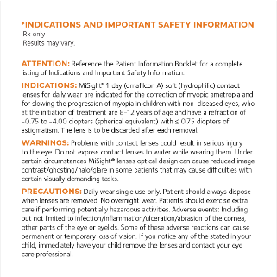

*‡Only FDA-approved soft contact lens designed for myopia control in the U.S.*

*§Compared to a single-vision 1-day lens over a 3-year period.*

*1Theophanous C, Modjtahedi BS, Batech M, Marlin DS, Luong TQ, Fong DS. Myopia prevalence and risk factors in children. Clin Ophthalmol. 2018;12:1581-1587. Published 2018 Aug 29. doi:10.2147/OPTH.S164641*

*2Chamberlain P, et al. A 3-year Randomized Clinical Trial of MiSight® Lenses for Myopia Control. Optom Vis Sci.2019; 96(8)556-567*

**Post #2: (video)**

Vera, age 10, patient story video   
([download video to include](https://dixonschwabl.sharefile.com/share/view/sda4a608c88354cb59eb3481a6e1b1d21))

“I couldn’t look at the board, I couldn’t see the TV, I couldn’t play video games. So that was a really big problem for me.” – Vera, age 10

When Vera noticed she was struggling with everyday activities, she knew something was wrong. Given her mom’s history of severe nearsightedness, known as myopia, her eye doctor prescribed immediate treatment with MiSight® 1 day contact lenses for age-appropriate children1,2.

[#Myopia](https://www.facebook.com/hashtag/myopia?__eep__=6&__cft__%5b0%5d=AZV19k_oyBLLxGqhPpdTGVsMHOBfA1RzGvhQ7JKKL-786TDMrX8hHWo72WxmFjlxsfc_olOB_2Mn3iXp1efaztDoZSixYyx-cjUMWXDZV71PL8_UAHDJeQc2DHWqoH1kqMovKgWnTrF4cgyB1V6w707Rs5kjdq0k9TC_AlSkHmse5zkKodIaO4TtOBme4_DwzUs&__tn__=*NK-R) [#ChildrensEyeHealth](https://www.facebook.com/hashtag/childrenseyehealth?__eep__=6&__cft__%5b0%5d=AZV19k_oyBLLxGqhPpdTGVsMHOBfA1RzGvhQ7JKKL-786TDMrX8hHWo72WxmFjlxsfc_olOB_2Mn3iXp1efaztDoZSixYyx-cjUMWXDZV71PL8_UAHDJeQc2DHWqoH1kqMovKgWnTrF4cgyB1V6w707Rs5kjdq0k9TC_AlSkHmse5zkKodIaO4TtOBme4_DwzUs&__tn__=*NK-R) [#KidsEyeHealth](https://www.facebook.com/hashtag/kidseyehealth?__eep__=6&__cft__%5b0%5d=AZV19k_oyBLLxGqhPpdTGVsMHOBfA1RzGvhQ7JKKL-786TDMrX8hHWo72WxmFjlxsfc_olOB_2Mn3iXp1efaztDoZSixYyx-cjUMWXDZV71PL8_UAHDJeQc2DHWqoH1kqMovKgWnTrF4cgyB1V6w707Rs5kjdq0k9TC_AlSkHmse5zkKodIaO4TtOBme4_DwzUs&__tn__=*NK-R)

*1 Soft contact lens designed for myopia control in the U.S.*

*2 Indications for use: MiSight® 1 day (omafilcon A) soft (hydrophilic) contact lenses for daily wear are indicated for the correction of myopic ametropia and for slowing the progression of myopia in children with non-diseased eyes, who at the initiation of treatment are 8-12 years of age and have a refraction of -0.75 to -4.00 diopters (spherical equivalent) with 0.75 diopters of astigmatism. The lens is to be discarded after each removal.*

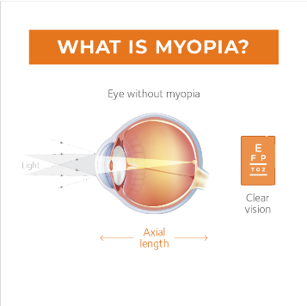**Post #3:** **(2-image swipe)**

[#Myopia](https://www.facebook.com/hashtag/myopia?__eep__=6&__cft__%5b0%5d=AZVYgslKoGJZ608UFZqE1dc-GtBPpAP9bthRP30kk6CVRdSPd8ezGMjaNZRKfE2wSIiLEBHGFcLGvUPHAagsemRyHkHCdH6hU1VQ9QGS_JmtfbBoGGnDVJZNFEuuwIf_no4v-V5_tUNioTdN0pf1R7GBeUY0A9hbwNnPL6I-siRzmhaenGSwgr2woiPXeo-AAF4&__tn__=*NK-R) happens when the eye grows longer and faster than it should. This creates blurry images on the retina, almost like a camera that’s out of focus.

Wondering what else leads to myopia? Read more in this blog post from Cooper Vision: [bit.ly/3nDmR91](https://bit.ly/3nDmR91?fbclid=IwAR3bkakx1I1xgHK_MM9OZ10YMdRmbkL3BZUouzwzmrAxMErD3D4y2wzXnvA)

